Use-Case and Class Diagram
Use-Case Diagram:
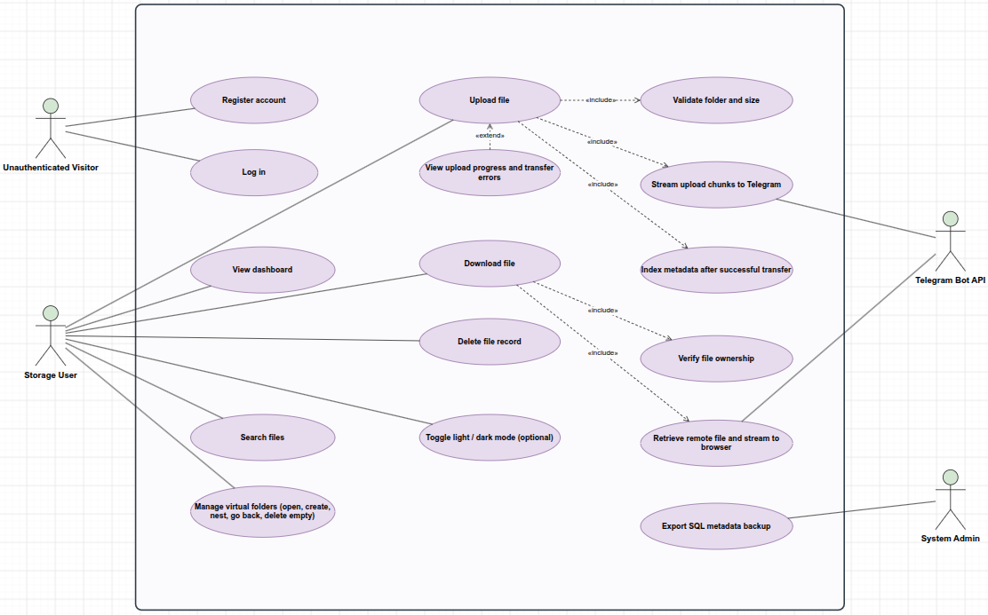

Class Diagram:


